1. **Apply conditional formatting to highlight cells in the Sales column (D) with values greater than or equal to 150.**

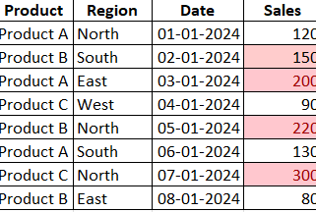

1. **Apply conditional formatting to highlight the entire row for entries where the Product is "Product A".**

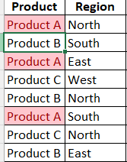

1. **Apply conditional formatting to highlight cells in the Date column (C) that fall within January 2024.**

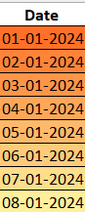

1. **Apply conditional formatting to highlight the top 3 sales values in the Sales column (D).**

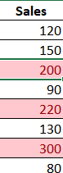

1. **Apply conditional formatting to highlight sales for "Product B" in the "North" region.**

